Software Requirements Specification
for
MyTax
Version 2.0
Prepared by:
Francisco Aguirre
Gustavo Montes
Jose Carlos Martinez
Jorge Origel
Benjamin Villegas

Nov-2013
Table of Contents
Table of Contents ii
Revision History ii
1. Introduction 1
1.1 Purpose 1
1.2 Document Conventions 1
1.3 Intended Audience and Reading Suggestions 1
1.4 Project Scope 1
1.5 References 1
2. Overall Description 2
2.1 Product Perspective 2
2.2 Business Requirement 3
2.3 User Classes and Characteristics 3
2.4 Operating Environment 3
2.5 Design and Implementation Constraints 4
2.6 User Documentation 4
2.7 Assumptions and Dependencies 4
3. System Requirements 4
3.1 Android Platform Development 4
3.1.1 Description and Priority 4
3.1.2 Requirements: 4
3.2 Deductions, Incomes and Withholdings 5
3.2.1 Description and Priority: 5
3.2.2 Requirements: 5
3.3 Tax Calculation 5
3.3.1 Description and Priority: 5
3.3.2 Requirements: 6
3.4 SAT Regulations 6
3.4.1 Description and Priority: 6
3.4.2 Requirements: 6
4. External Interface Requirements 7
4.1 User Interfaces 7
4.2 Hardware Interfaces 7
4.3 Software Interfaces 7
5. Other Nonfunctional Requirements 8
5.1 Performance Requirements 8
5.2 Security Requirements 8
5.3 Software Quality Attributes 8
Appendix A: Glossary 8

Revision History
Name | Date | Reason For Changes | Version
Francisco Aguirre  Gustavo Montes  Jose Carlos Martinez  Jorge Origel  Benjamin Villegas | 27-SEP-13 | Initial Version | 1.0
Francisco Aguirre  Gustavo Montes  Jose Carlos Martinez  Jorge Origel  Benjamin Villegas | 4-nov-13 | Corrections from V1 review | 2.0

Introduction

Purpose
The purpose of this document is provided the functional and non-functional requirements of MyTax application for Release 1.

Document Conventions
- Documentation base on IEEE 830 Templates.
- Font typographic: Arial 11 points.

Intended Audience and Reading Suggestions
- Sponsors – Full Document
- Designers – Full Document
- Developers – Functional & Non-Functional Requirements
- Testers - Functional & Non-Functional Requirements

Project Scope
My taxes will have capabilities for calculating the amount of taxes to be paid every year by the users. The application will calculate the amount of money that the user can have in return because of the deductions during the year. User will have a list of recommendations that can help for better deductions. The application will be run in Android OS.

References
- Templates: www.processimpact.com

Overall Description

Product Perspective
MyTax is a standalone application which will be deployed in devices with Android operating system

Integration Diagram



SAT regulations

My Tax

Functional Diagram



Expenses

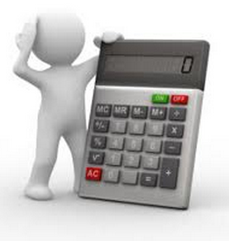
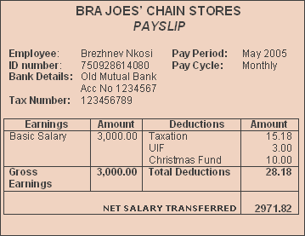



Incomes and Withholdings


MyTax
Calculation
Potential
Tax Return

Deductions

Business Requirement

REQ - 2.2.1: System shall allow user to store expenses for available deductions for actual SAT regulations during the year.
i.e. College fees, investments, charity,

REQ - 2.2.2: System shall allow user to store income salary per month and the must calculate the annual income to be use as the base for the TAX calculation
i.e. A person wins 10,000 per month. System calculates an annual income of 120,000.

REQ - 2.2.3: System shall allow user to store other income that are part of the annual Base amount for the tax calculation.
i.e. Christmas bonus, profit bonus, vacation bonus, or leasings.

REQ - 2.2.4: System shall calculate total Annual income (Sum from requirement 2 and 3) to be use as base for the annual Income.

REQ - 2.2.5: System shall calculate Total Deductions; sum of deductions per year based on the actual SAT table deduction rates.

REQ - 2.2.6: System shall allow to the user store withholdings during the year and then calculate the return of money to receive form the SAT.

REQ - 2.2.7: System shall calculate ISR TAX over the annual income using actual SAT table rates. This is the total income minus the deductions and this result is used to calculate the TAX

REQ - 2.2.8: System shall be able to update SAT regulations and tables for the ISR and Deductions rates.

REQ - 2.2.9: System shall provide guidance to manage deductible expenses, based on the actual SAT regulations.

User Classes and Characteristics
- Client – User of Application
- Administrator – On charge of updating data in the server

Operating Environment
The users will be in Mexico, the laws applied for the application are based in SAT restrictions. The information provided from SAT is the same for every state in Mexico, and the application will be run in Android. The system must be available any time the user wants to enter and input data.

The data will be generated in the users’ cell phones and sync with the remote server. If the user doesn’t have internet access, it should be any restriction for the application to work. The application will have an option to set a password to access the application.

Design and Implementation Constraints
- SAT regulations
- Java 1.7
- Web Services
- Android SDK 4.0+
- Android Development Tools for Eclipse
- SQLite 3.7.x

User Documentation
- Mytax User’s Guide
- Mytax code for Android devices

Assumptions and Dependencies
- User is an individual working in Mexico under ‘Personas Fisicas’ regime.
- User has a mobile platform like a PDA, phone or Tablet using Android 4.0+ as operating system.
- User has information about gross salary and withholdings for his/her incomes.
- User will follow the process required to declare the taxes and any possible withholding.
- User is requesting invoices or any required document needed for all available expenses to be deducted.
- User understands English.

System Requirements

Android Platform Development

Description and Priority
LOW PRIORITY feature.
The system needs to work only for Android Platform. This is a mobile application which will help users to be updated about deductions and income of taxes. This application will connect to a remote database in order to synchronize SAT regulations. For Device (Android OS), it will be managed by SQLite.

Requirements:
REQ- 3.1.2.1: System shall be build on mobile device with android platform

REQ- 3.1.2.2: System shall be able to connect to a remote database to update the actual SAT regulations

REQ- 3.1.2.3: System shall have good performance to calculate and display results.

REQ- 3.1.2.4: System shall store all user data on the mobile device using a SQLITE database.

REQ- 3.1.2.5: System shall store all SAT regulations on the mobile device using a SQLITE database (same database from REQ- 3.1.2.4).

Deductions, Incomes and Withholdings

Description and Priority:
HIGH PRIORITY feature.
The system will store all deductions, incomes and withholdings related to the customer of the application (previously installed in the mobile). All SAT regulations need to be loaded into the mobile database, so user will be able to introduce all inputs performed along the fiscal year.
Deductions as charity, college fees, investments, etc. can be added by SAT regulations.

Requirements:
REQ- 3.2.2.1: System shall allow user store income salary per month and number of times that apply.
REQ- 3.2.2.2: System shall allow user store withholdings for the salary per month and number of times that apply.
REQ- 3.2.2.3: System shall allow user to store other incomes that are part of the taxable annual amount.

REQ- 3.2.2.4: System shall allow user to store expenses for available deductions from the SAT regulation during the fiscal year.

Tax Calculation

Description and Priority:
HIGH PRIORITY feature.
The system will calculate the ISR TAX over the fiscal year based on SAT rates, expenses, withholdings and salary entered for the fiscal year to calculate.

Requirements:
REQ-3.3.2.1: System shall calculate total annual income. This is the sum from all the incomes (multiplied for the times that apply) entered by user for a fiscal year.

REQ-3.3.2.2: System shall calculate total deductions; sum of deductions per year based on the actual SAT deduction rules for a fiscal year.

REQ-3.3.2.3: System shall calculate the total withholdings during the fiscal year.

REQ-3.3.2.4: System shall calculate ISR TAX over the annual taxable amount (this is the total income minus the deductions) using SAT regulation table rates.

REQ-3.3.2.5: System shall calculate Return or Debt using the ISR TAX calculated minus the withholdings.

REQ-3.3.2.6: System shall provide guidance to manage deductible expenses, based on the actual SAT regulations.

SAT Regulations

Description and Priority:
The system shall be up-to-date with the actual SAT regulations. Remote database contains SAT regulations by fiscal year.

Requirements:
REQ-3.4.2.1: Remote Server store actual SAT regulations by Fiscal Year. It is updated manually by MyTax team.

REQ-3.4.2.2: Remote Server store actual SAT regulations in a SQLITE database.

External Interface Requirements

User Interfaces
This application will be a mobile app, there will be some user screens to perform following activities:

Prototype : https://moqups.com/villegasben/XmAbEqOz/

REQ 4.1.1: Account setup page.

REQ 4.1.2: Page with SAT regulation guide for a fiscal Year.

REQ 4.1.3: Page to enter deductions.

REQ 4.1.4: Page to enter withholding.

REQ 4.1.5: Page to enter incomes.

REQ 4.1.6: Page to calculate ISR Taxes with deductions.

REQ 4.1.7: Page to calculate ISR Taxes without deductions.

Hardware Interfaces
REQ 4.2.1: These all pages will be supported in all Android devices with version 4.0+

REQ 4.2.2: The mobile should have 100 MB free to be assigned to this application (application itself, local database (SQLite)).

Software Interfaces
REQ 4.3.1: Software will be developed in JAVA using Eclipse as development tool, with Android SDK, the version used is 4.0+.

REQ 4.3.2: The operating system to develop this application will be Windows 7.

REQ 4.3.3: The application will interact with local database using SQLite.

REQ 4.3.4: The operating system to create SQLite database will be windows 7.

REQ 4.3.5: When device is connected to internet user can synchronize Local Database with SAT regulations from remote database

Other Nonfunctional Requirements

Performance Requirements
REQ 5.1.1: Response time for calculating taxes should be no more than 10 seconds.

Security Requirements
REQ 5.2.1: The user will have the option to enable a 4 numeric digit password, by default the application won’t have this option enabled.

Software Quality Attributes
REQ 5.3.1: The application should work with and without Internet connection.

Appendix A: Glossary
- Persona física: person with the capacity of contracting rights and liabilities under a salary schema.

- SAT: Secretaria de Administración Tributaria (Mexican Local Tax Authority)

- ISR: Impuesto sobre la renta (Income Tax)

- Tax: Financial charge or other levy imposed upon a taxpayer

- Tax deduction: a reduction in the gross amount on which a tax is calculated; reduces taxes by the percentage fixed for the taxpayer's income bracket.

- Withholding: government requirement for the payer of an item of income to withhold or deduct tax from the payment
Appendix B: Tax Calculation Rules
- Calculate the sum of incomes, by default the data entered is validated to be a positive amount.

- Calculate the sum of Withholdings.

- Calculate valid deductions:

  - Each entered deduction is recalculated and validated to the limits defined by the tax authority.
e.g.

User entered a deduction for 5,000 pesos for glasses and the limit is 2,500.
User entered a deduction for 17,000 pesos for school “PRIMARIA” and the limit is for 12,500.

- Calculate the sum of valid deductions

- Calculate the Taxable Amount. This is the sum of incomes minus sum of deductions.

- Calculate Tax:

  - Look the Taxable amount in the actual ISR tax table.
  - Tax is equal to the Fix Charge plus the exceeding amount from the low limit multiplied for the tax rate.

- Calculate balance. It is the withholdings minus the Tax.

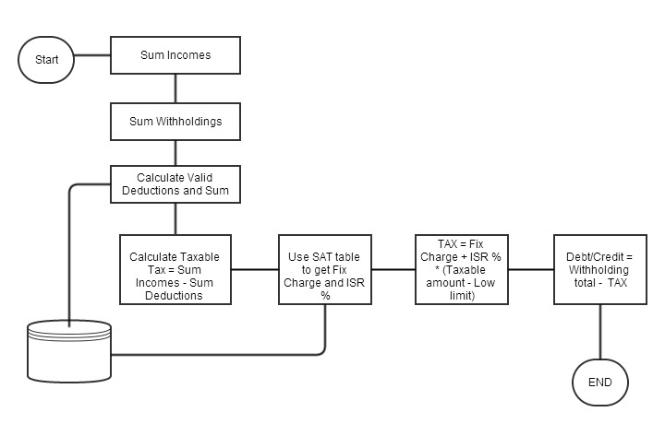
Appendix C: 2013 Tax Rates table

Low limit |  | High Limit |  | Fix Charge |  | Tax Rate
$ |  | $ |  | $ |  | %
0.01 |  | 5,952.84 |  | 0.00 |  | 1.92
5,952.85 |  | 50,524.92 |  | 114.24 |  | 6.40
50,524.93 |  | 88,793.04 |  | 2,966.76 |  | 10.88
88,793.05 |  | 103,218.00 |  | 7,130.88 |  | 16.00
103,218.01 |  | 123,580.20 |  | 9,438.60 |  | 17.92
123,580.21 |  | 249,243.48 |  | 13,087.44 |  | 21.36
249,243.49 |  | 392,841.96 |  | 39,929.04 |  | 23.52
392,841.97 |  |  |  | 73,703.40 |  | 30.00

